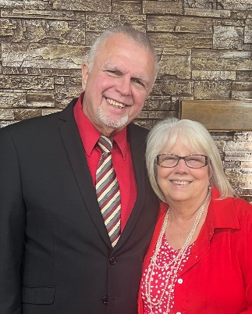
MERRY CHRISTMAS
TONY AND TAMMY HONEYCUT AND
PIEDMONT RESCUE MISSION
STAFF & MEN
Psalm 34:8 “O taste and see that the Lord is good: blessed is the man that trusteth in Him.”
What a blessed time we are approaching this month, the birth of our Savior,” Jesus”. We pray God will touch many hearts this year at Christmas to celebrate the birth of Jesus, the true meaning of Christmas.
The whole month will be filled with to do list, shopping for gifts, wrapping of gifts, and then giving out the gifts on Christmas Day. As we run about in the hustle and bustle let us not forget the greatest gift of all cost us nothing. Jesus gave the ultimate gift to us, His life. Without Him there would be no Christmas.
I remember when we were in Kenya, our first Christmas was so different than they are here. Being new to the country was already an adjustment and then when Christmas rolled around, we were stuck wondering what we would do for our children for Christmas. The girls were so good adjusting to the changes and even at Christmas they were happy. They all wanted African wood carvings and souvenirs, which was perfect. The one thing that made that Christmas special was we went to church. Christmas to the Christians in Kenya was all about Jesus. The children, if they got anything it would be a new outfit which they were so proud of. At times, we miss the slow pace of living where we could just enjoy being together without the constant running from one event to the other.
As we prepare for the Christmas Community Event here at PRM we are asking for help from volunteers and donations for the event. I have a list of needs on the back of the letter if God lays on your heart to help us and if you would like to volunteer the day of the event, please call the office and let Tammy know so she can put you on the list.
Christmas can be a hard time for our men here at the mission so we try to get a nice gift bag up for them full of toiletries, belts, wallets, Walmart gift cards and candy. If you would like to help us, make this year special for them by helping with donations toward these gift bags it would be appreciated. Thank you in advance for all you do to help PRM at Christmas.
We ask that you please continue praying for the Women and Children’s Shelter in regards to the sprinkler system issue. It is still being addressed and we will let you all know as soon as we do know what the final result is.
We do hope you all have a Wonderful Christ filled Christmas this year and a Happy New Year!

Tony & Tammy Honeycutt -Phil 4:13

